February 12th, 2006
Hi
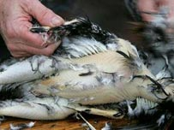
Not much to write about so will include a few pictures to fill up the space.
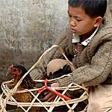
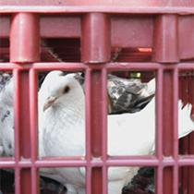
A lot of the news in the past week in HK has bee about bird flu. More dead birds have been found to be infected with the H5N1 virus. Of course, more birds die at this time of the year because of the cooler weather and greater difficulty in finding food. Getting close to here too with an infected dead bird found in the street in Tuen Mun. Two were also found in the grounds of Diocesan Boys School in Mong Kok. Also, at Sha Tau Kok. the village that straddles the border, a lady bought an infected chicken from a market in China smuggled it back onto the HK side. Because of all this, the government passed a bill this past week banning the keeping of live poultry in backyards. In addition, chickens in markets can no longer be taken home live but must be killed by the vendor first. Racing pigeons are also affected, with a $10 000 licence now needed to keep them and strict conditions for looking after them in place. The high fee doubtless is to dissuade people from keeping their pigeons. Even vendors in Bird Street are doing less business now that many wild birds are infected. And with the virus now in Africa, it seems unavoidable that it will soon be everywhere in the world. Of course, in past years, similar things probably happened with other bird viruses but nobody was investigating them then.
A dead H5N1 infected wild bird
Racing pigeons in Hong Kong
Banned!

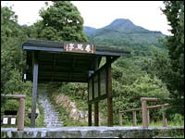
Friday last was the 10th anniversary of the hill fire that killed two teachers and three students who were out hiking up Pat Sing Leng. Do you remember the fire? It was believed, but never proved, that the fire was caused by some of the students themselves who were at the back of the group. As the others were on the uphill side and the undergrowth was very dry, the fire quickly spread, trapping them. Near the beginning of the track that goes around the edge of the Pat Sing Leng range there is a memorial to the fire victims (see photo); I pass the memorial on my hikes in the area.
The Pat Sin Leng mountain range
The pavilion-memorial
to the hill fire victims
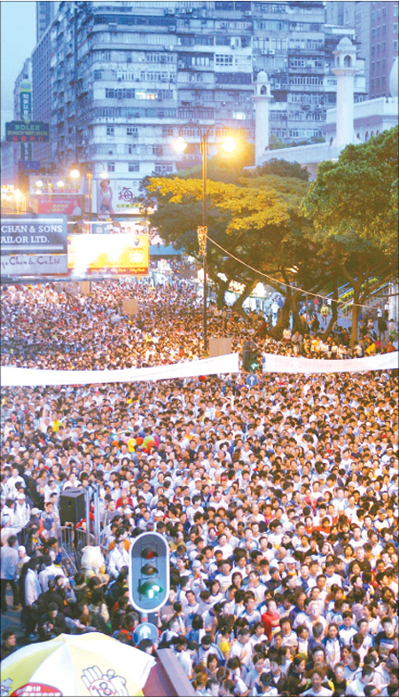
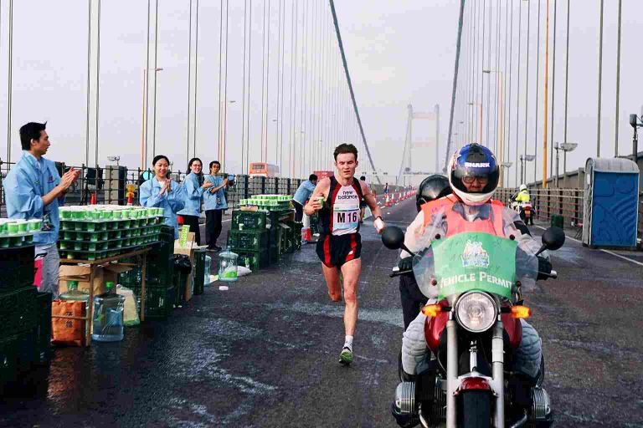
Went for a run last Tuesday instead of Monday. We run in the Tai Lam Chung area. Took 2 hr 31 min, which was 4 min faster than last year's run. Tomorrow, we go for a run around the Plover Cove reservoir. The HK marathon was run this morning. It starts from outside the mosque in Nathan Road, proceeds up the West Kowloon highway, across the Tsing-Ma Suspension bridge, then back again and through the tunnel to finish on HK side. The race starts early in the morning to keep traffic disruption to a minimum. Conditions today would be quite good – not the cold, wet and windy conditions they had last year.
Start of the 2005
HK marathon
Crossing the Tsing Ma bridge
during the 2003 marathon

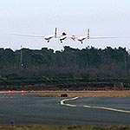
Read in the news today that the US billionaire adventurer Steve Fossett set another long-distance flying record. He flew non-stop from the US around the world and then continued across the Atlantic for a second time and landed in the south of England.
Crossing the Atlantic
Landing in England
That’s about it for this time.

Cheers.

